**“I MUST ALSO SEE ROME”**

Acts 19:21–20:12

Key Verse: 19:21

1. Referring to the map, briefly review the highlights of what God had done on Paul’s first (13:1–14:28), second (15:36–18:22), and third missionary journeys (18:23–19:20). Through the Jerusalem Council, what crisis had been averted (15:1–35)? In all this, what strategies for spreading the gospel has Paul learned?
2. What are his plans now, and what is the Spirit’s role in this (19:21)? Why does he want to “pass through Macedonia and Achaia” first (20:2; cf. 14:22; 15:41; 18:23)? Why does he want to go to Jerusalem (Rom.15:25–27)? Why to Rome (Rom.1:9–15)? Why does he first stay in Ephesus (22; 1 Cor.16:8–9)?
3. What motivates the riot in Ephesus (23–29)? Who protects Paul (30–31)? How else is the riot described (32–34)? How are things calmed down (35–41), and why does Luke include this story?
4. How does Paul begin to follow through with his travel plans (20:1–3)? Who is with him (4), and why does he take them with him to Jerusalem (2 Cor.8:19–20; 3:2–3)?
5. Read 20:5–6 and find Troas on a map. When had Paul been there before (16:8–11)? How does he minister there now (20:7–8)? What happens (9–12), and what does this incident show us about Paul?
6. Read 19:21 again. Why should we as Christians focus on both strengthening the church and spreading the gospel to unreached people and places (Rom.15:20–21)? What can we learn from Paul about how not to get distracted but follow God’s plan for us?

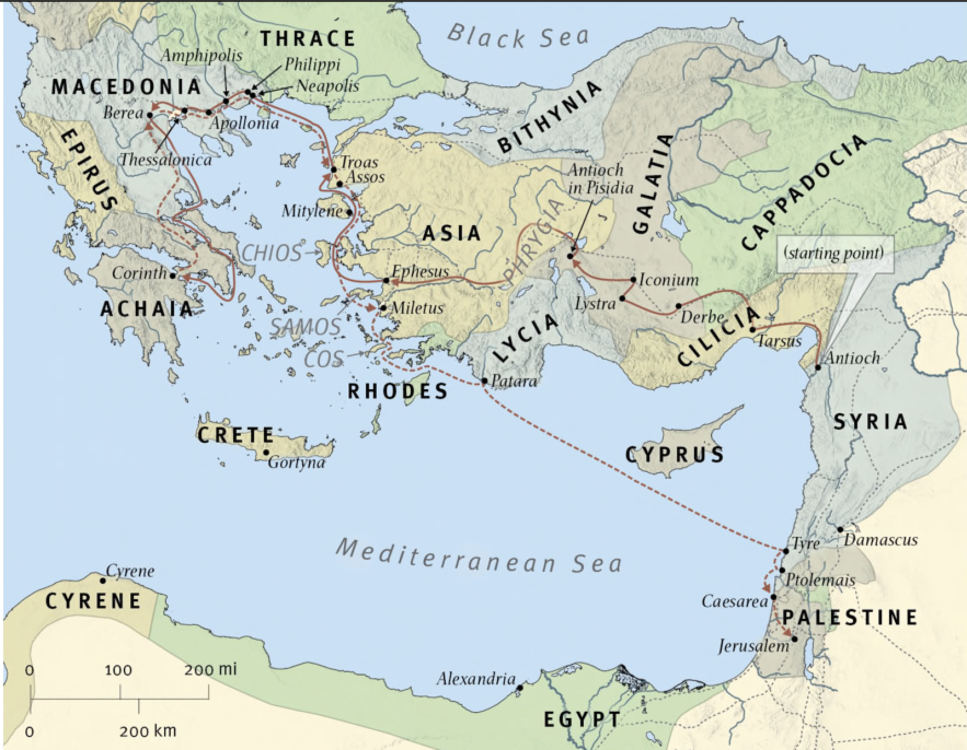

References:

**Q2**: Acts 14:22: “...strengthening the souls of the disciples, encouraging them to continue in the faith, and saying that through many tribulations we must enter the kingdom of God.”

15:41: “And he went through Syria and Cilicia, strengthening the churches.”

18:23: “After spending some time there, he departed and went from one place to the next through the region of Galatia and Phrygia, strengthening all the disciples.”

Rom.15:25–27: “At present, however, I am going to Jerusalem bringing aid to the saints. For Macedonia and Achaia have been pleased to make some contribution for the poor among the saints at Jerusalem. For they were pleased to do it, and indeed they owe it to them. For if the Gentiles have come to share in their spiritual blessings, they ought also to be of service to them in material blessings.”

1:9–15: “For God is my witness, whom I serve with my spirit in the gospel of his Son, that without ceasing I mention you always in my prayers, asking that somehow by God’s will I may now at last succeed in coming to you. For I long to see you, that I may impart to you some spiritual gift to strengthen you––that is, that we may be mutually encouraged by each other’s faith, both yours and mine. I do not want you to be unaware brothers, that I have often intended to come to you (but thus far have been prevented), in order that I may reap some harvest among you as well as among the rest of the Gentiles. I am under obligation both to Greeks and to barbarians, both to the wise and to the foolish. So I am eager to preach the gospel to you also who are in Rome.”

1 Cor.16:8–9: “But I will stay in Ephesus until Pentecost, for a wide door for effective work has opened to me, and there are many adversaries.”

**Q4**: 2 Cor.8:19–20: “And not only that, but he has been appointed by the churches to travel with us as we carry out this act of grace that is being ministered by us, for the glory of the Lord himself and to show our good will. We take this course so that no one should blame us about this generous gift that is being administered by us…”

3:2–3: “You yourselves are our letter of recommendation, written on our hearts, to be known and read by all. And you show that you are a letter from Christ delivered by us, written not with ink but with the Spirit of the living God, not on tablets of stone but on tablets of human hearts.”

**Q5**: Acts 16:8–11: “So, passing by Mysia, they went down to Troas. And a vision appeared to Paul in the night: a man of Macedonia was standing there, urging him and saying, ‘Come over to Macedonia and help us.’ And when Paul had seen the vision, immediately we sought to go on into Macedonia, concluding that God had called us to preach the gospel to them.”

**Q6**: Rom.15:20–21: “...and thus I make it my ambition to preach the gospel, not where Christ has already been named, lest I build on someone else’s foundation, but as it is written, ‘Those who have never been told of him will see, and those who have never heard will understand.’”